Epsom & Ewell F.C.
11
v
Molesey
Saturday, 22nd November 2014
For our League match this afternoon we welcome the players, officials and supporters of Molesey Football Club, along with today's match officials and of course our own regular supporters.

Today’s visitors have had a superb start to the season, announcing themselves as one of the teams to beat when winning 9-0 at Chertsey Town back in August. They remain well in contention for the single promotion place at this stage.

For our part, it has been a tough few weeks but I think we are coming out of the tunnel once again now and today will show whether we can maintain our recent performance level. Our home defeat by Chertsey last time we were here marked our fourth straight League loss, equalling the worst run of form in the Division. Then we were heavily beaten 5-1 at Lingfield to end any hope of a Vase run; a competition where we will surely be back in the qualifiers next season.

Since then we travelled to Bedfont Sports where we broke our losing run with a fine 2-0 win. Taylor Smith scored both of our goals but it was a solid team performance from start to finish. This was followed by a visit to Cove where we were narrowly defeated by a goal to nil after having the majority of the chances.

Then on Tuesday we made the short hop to Cobham for a League match with Mole Valley SCR where we played really well in winning 5-2. Although it was a fantastic team performance, it was also good to see Kyle Hough record his fifth hat-trick in Epsom colours, the first person to do that since Steve Hill back in the eighties.

You will note that our players are now wearing our new kit, generously provided by Intercem. Our club is extremely grateful for the donation and we would remind people that we are taking orders for replica shirts at £25 so if you are interested, please let us know as soon as you can. We also launch our Predictor competition today and further details are on page 35 of the programme.

We travel to Guildford City this Saturday for a League match and return home for a Surrey Senior Cup tie with Camberley Town three days later.

Enjoy the game!

Rich (Richard.c.lambert@gmail.com) on Twitter @EEFCOfficial

Cover photo this week by Gemma Jarman

Taylor Smith forces home our first goal in the 2-0 win at
Bedfont Sports, two weeks ago today.

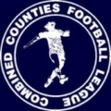
Cherry Red Records
Combined Counties League
Premier Division Table 2014/15
inc 18th November 2014 | P | W | D | L | F | A | Pts | GD | H | A
Cove | 18 | 14 | 3 | 1 | 41 | 21 | 45 | +30 | 7/3 | 0-1
Ashford Town (Mx) | 16 | 13 | 2 | 1 | 42 | 12 | 41 | +30 | 2-4 | 10/1
Windsor | 16 | 11 | 2 | 3 | 41 | 20 | 35 | +21 | 3/1 | 11/4
Molesey | 15 | 11 | 0 | 4 | 48 | 16 | 33 | +32 | 22/11 | 28/2
Camberley Town | 16 | 10 | 3 | 3 | 31 | 10 | 33 | +21 | 7/2 | 0-1
Spelthorne Sports | 15 | 10 | 2 | 3 | 30 | 19 | 32 | +11 | 11/11 | 3-0
Hartley Wintney | 17 | 9 | 3 | 5 | 22 | 22 | 30 | 0 | 21/2 | 1-2
Epsom & Ewell | 19 | 8 | 2 | 9 | 34 | 27 | 26 | +7 | X | X
Colliers Wood United | 18 | 7 | 2 | 9 | 31 | 31 | 23 | 0 | 4/4 | 2-3
Mole Valley SCR | 19 | 6 | 4 | 9 | 36 | 43 | 22 | -7 | 1-0 | 5-2
Badshot Lea | 20 | 6 | 4 | 10 | 34 | 41 | 22 | -7 | 21/3 | 13/12
Bedfont Sports | 16 | 7 | 1 | 8 | 23 | 30 | 22 | -7 | 0-1 | 2-0
Raynes Park Vale | 16 | 5 | 4 | 7 | 22 | 27 | 19 | -5 | 0-1 | 27/12
Farnham Town | 18 | 5 | 4 | 9 | 31 | 40 | 19 | -9 | 17/1 | 2-0
Frimley Green | 17 | 5 | 4 | 8 | 29 | 38 | 19 | -9 | 0-0 | 25/4
Chertsey Town | 17 | 6 | 1 | 10 | 24 | 38 | 19 | -14 | 1-2 | 14/3
Knaphill | 17 | 5 | 3 | 9 | 19 | 42 | 18 | -23 | 18/4 | 4-1
Horley Town | 17 | 4 | 4 | 9 | 33 | 40 | 16 | -7 | 2-2 | 6/4
Westfield | 19 | 4 | 3 | 12 | 23 | 38 | 15 | -15 | 31/1 | 0-4
Guildford City | 18 | 4 | 1 | 13 | 28 | 51 | 13 | -23 | 4-1 | 29/11
Hanworth Villa | 16 | 3 | 2 | 11 | 19 | 35 | 11 | -16 | 6/12 | 5-2

Lucky Day? – 22nd November
Played 11 - Won 8 Drawn 1 Lost 2 - F 31 A 16 - PPG 2.27 - Fantastic!
Club record against Molesey
Played 42 - Won 20 Drawn 10 Lost 12 - F 56 A 51 - PPG 1.67 - Above Average
Last visit
Saturday 1st March 2014 - Drew 2-2 - Combined Counties League

First Eleven Appearances - (max 24 inc Mole Valley SCR)
Name | Debut | 2014/15 |  |  |  | Career Totals
 |  | App | Sub | Total | Goals | App | Sub | Total | Goals
BROWN Oshane* | 30/08/2014 | 2 | 0 | 2 | 0 | 2 | 0 | 2 | 0
CURRIE Sam | 04/08/2012 | 2 | 0 | 2 | 0 | 96 | 5 | 101 | 2
DEAN Dan | 02/08/2014 | 20 | 1 | 21 | 0 | 20 | 1 | 21 | 0
DEWAR Ali | 29/10/2011 | 5 | 2 | 7 | 3 | 55 | 31 | 86 | 10
DOUGLIN Karl* | 03/08/2013 | 1 | 0 | 1 | 1 | 41 | 3 | 44 | 14
DOWNS Carl* | 17/09/2011 | 4 | 1 | 5 | 0 | 94 | 13 | 107 | 2
EACOTT Michael | 02/08/2014 | 22 | 0 | 22 | 0 | 22 | 0 | 22 | 0
FARRELL Matt | 02/08/2014 | 23 | 1 | 24 | 2 | 23 | 1 | 24 | 2
FERDINANDO Matt | 20/09/2014 | 11 | 3 | 14 | 2 | 11 | 3 | 14 | 2
GAFFNEY Luke | 16/08/2014 | 10 | 1 | 11 | 0 | 10 | 1 | 11 | 0
HARPER Tommy* | 15/04/2014 | 1 | 0 | 1 | 0 | 2 | 1 | 3 | 0
HAYWARD Ben | 07/03/2007 | 5 | 0 | 5 | 0 | 241 | 28 | 269 | 18
HOADLEY Harry | 15/04/2014 | 6 | 1 | 7 | 0 | 7 | 1 | 8 | 0
HOUGH Kyle | 14/08/2007 | 20 | 1 | 21 | 9 | 274 | 13 | 287 | 146
JARMAN Mark | 08/08/2009 | 5 | 5 | 10 | 0 | 136 | 51 | 187 | 76
MARVELL Dale | 15/01/2000 | 11 | 5 | 16 | 5 | 261 | 45 | 306 | 85
MCGREGOR Alex | 08/08/09 | 3 | 0 | 3 | 0 | 160 | 54 | 214 | 26
MURPHY George | 28/03/2013 | 1 | 3 | 4 | 0 | 66 | 25 | 91 | 7
MUTIMA Lionel | 05/08/2014 | 17 | 1 | 18 | 1 | 58 | 5 | 63 | 3
NELMES Elliott* | 05/08/2014 | 4 | 2 | 6 | 0 | 4 | 2 | 6 | 0
PANAYI Anthony | 14/11/2010 | 2 | 0 | 2 | 0 | 2 | 0 | 2 | 0
ROBINSON Matt | 01/12/2012 | 16 | 1 | 17 | 0 | 143 | 15 | 158 | 4
ROBINSON Sam | 22/10/2011 | 7 | 1 | 8 | 0 | 8 | 4 | 12 | 1
ROWE Steve | 27/08/2011 | 14 | 1 | 15 | 6 | 38 | 4 | 42 | 11
SHAW Ollie | 20/09/2014 | 1 | 0 | 1 | 0 | 6 | 1 | 7 | 0
SMITH Taylor | 02/08/2014 | 0 | 10 | 10 | 0 | 0 | 10 | 10 | 0
TANTON Matt | 02/08/2014 | 13 | 1 | 14 | 7 | 13 | 1 | 14 | 7
TAYLOR James | 26/08/2013 | 15 | 2 | 17 | 1 | 15 | 2 | 17 | 1
VAN GELDER Julian* | 12/09/2006 | 17 | 1 | 18 | 1 | 34 | 7 | 41 | 2
WHITE Sean | 02/08/2014 | 0 | 1 | 1 | 0 | 0 | 2 | 2 | 0
Own Goal |  |  |  |  | 1
* Player has left the club

Results and Fixtures
Combined Counties League – Tuesday 28th October
Epsom & Ewell | 1-2 | Chertsey Town
Mole Valley SCR | 1-2 | Hartley Wintney
Westfield | 1-2 | Windsor
F.A. Vase First Round – Saturday 1st November
Ashford Town (Mx) | 2-3 | Loxwood
Colliers Wood United | 4-3 | Ringmer
Chertsey Town | 1-2 | Horley Town
Chessington & Hook United | 2-1 | Camberley Town
Farnham Town | 3-3+ | Abingdon United
Lingfield | 5-1 | Epsom & Ewell
Littlehampton | 4-2 | Guildford City
Lordswood | 0-1 | Knaphill
Pagham | 2-1 | Spelthorne Sports
Raynes Park Vale | 1-3 | Westfield
Windsor | 1-4 | Highworth Town
Combined Counties League – Saturday 1st November
Badshot Lea | 3-4 | Mole Valley SCR
Frimley Green | 1-2 | Hartley Wintney
F.A. Vase First Round – Sunday 2nd November
Horsham YMCA | 3-1 | Bedfont Sports
F.A. Vase First Round Replay – Tuesday 4th November
Abingdon United | 5-1 | Farnham Town
Surrey Senior Cup Second Round – Tuesday 4th November
Woking | 0-3 | Ashford Town (Mx)
Combined Counties League – Saturday 8th November
Badshot Lea | 1-0 | Molesey
Bedfont Sports | 0-2 | Epsom & Ewell
Camberley Town | 1-0 | Hanworth Villa
Colliers Wood United | 1-2 | Guildford City
Farnham Town | 6-3 | Windsor
Frimley Green | 1-3 | Cove
Hartley Wintney | 0-0 | Ashford Town (Mx)
Knaphill | 2-1 | Mole Valley SCR
Raynes Park Vale | 2-4 | Westfield
Spelthorne Sports | 4-2 | Chertsey Town
Surrey Senior Cup Second Round – Tuesday 11th November
Godalming Town | 2-4 | Mole Valley SCR
Results and Fixtures
Combined Counties League Cup Second Round – Tuesday 11th November
Hanworth Villa | 2-3 | Guildford City
Combined Counties League – Tuesday 11th November
Badshot Lea | 3-0 | Westfield
Cove | 2-2 | Raynes Park Vale
Combined Counties League – Wednesday 12th November
Colliers Wood United | 4-2 | Farnham Town
Combined Counties League – Saturday 15th November
Ashford Town (Mx) | 3-2 | Badshot Lea
Bedfont Sports | 3-1 | Frimley Green
Chertsey Town | 2-1 | Raynes Park Vale
Cove | 1-0 | Epsom & Ewell
Guildford City | 2-3 | Hartley Wintney
Mole Valley SCR | Abandoned | Farnham Town
Molesey | 1-0 | Knaphill
Westfield | 0-2 | Spelthorne Sports
Windsor | 2-1 | Colliers Wood United
Surrey Senior Cup Second Round – Tuesday 18th November
Dorking Wanderers | 9-0 | Frimley Green
Combined Counties League – Tuesday 18th November
Badshot Lea | 2-2 | Hartley Wintney
Hanworth Villa | 4-3 | Horley Town
Mole Valley SCR | 2-5 | Epsom & Ewell
Surrey Senior Cup Second Round - Wednesday 19th November
Redhill | 2-1 | Raynes Park Vale
Game played at Raynes Park Vale FC
Combined Counties League Cup Second Round – Wednesday 19th November
Epsom Athletic | p-p | Banstead Athletic
F.A. Vase Second Round – Saturday 22nd November
Eastbourne United | V | Horley Town
Hanworth Villa | V | Knaphill
Pagham | V | Colliers Wood United
Westfield | V | Tunbridge Wells
Combined Counties League – Saturday 22nd November
Epsom & Ewell | V | Molesey
Farnham Town | V | Chertsey Town
Frimley Green | V | Mole Valley SCR
Results and Fixtures
Combined Counties League – Saturday 22nd November
Hartley Wintney | V | Cove
Raynes Park Vale | V | Ashford Town (Mx)
Spelthorne Sports | V | Guildford City
Windsor | V | Camberley Town
Combined Counties League – Tuesday 25th November
Ashford Town (Mx) | V | Windsor
Badshot Lea | V | Horley Town
Knaphill | V | Spelthorne Sports
Mole Valley SCR | V | Bedfont Sports
Westfield | V | Camberley Town
Surrey Senior Cup Second Round – Wednesday 26th November
Leatherhead | V | Farnham Town
Combined Counties League Cup Second Round – Saturday 29th November
Worcester Park | V | Chessington & Hook United
Combined Counties League – Saturday 29th November
Camberley Town | V | Hartley Wintney
Chertsey Town | V | Westfield
Colliers Wood United | V | Frimley Green
Cove | V | Spelthorne Sports
Guildford City | V | Epsom & Ewell
Hanworth Villa | V | Farnham Town
Knaphill | V | Horley Town
Mole Valley SCR | V | Windsor
Molesey | V | Bedfont Sports
Raynes Park Vale | V | Badshot Lea
Surrey Senior Cup Second Round – Tuesday 2nd December
Badshot Lea | V | Kingstonian
Epsom & Ewell | V | Camberley Town
Knaphill | V | Colliers Wood United
Tooting & Mitcham United | V | Horley Town
Combined Counties League Cup Third Round – Tuesday 2nd December
Windsor | V | Ash United
Combined Counties League – Tuesday 2nd December
Bedfont Sports | V | Raynes Park Vale
Chertsey Town | V | Ashford Town (Mx)

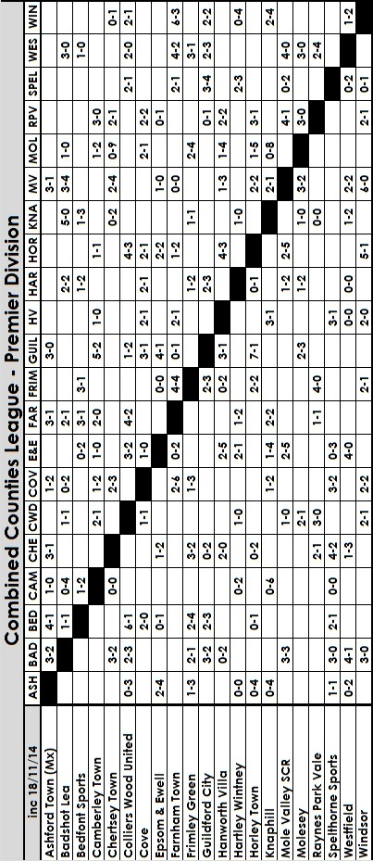

From behind the goal
Epsom & Ewell 1-2 Chertsey Town
Combined Counties League – Premier Division
Tuesday 28th October 2014

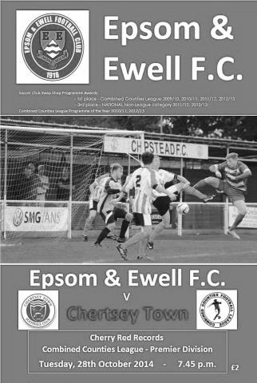
Nine man Curfews repel Salts charge

Following the promising but ultimately unsuccessful displays against two of the League's elite clubs, we faced a Chertsey Town side that had surprised everyone by struggling so badly in their attempts to return to the Southern League. However, our boys chose this night to produce their worst performance of the season, creating too little until it was far too late.

In addition to Taylor Smith's absence and Sam Robinson's suspension, our flying winger Ali Dewar was not available either and this left us unable to stretch the visitors with pace. Dale Marvell came in for him to provide a different type of threat on the left flank but we were otherwise unchanged from the narrow defeat at Camberley Town. For the opposition, there were two former Epsom players in the line-up. Neither had great days as Michael White, brother of our Cup winning keeper Joe, who had also played briefly for us last pre-season was back in their starting line-up after injury. The other was Steve Newman but more about him later.

A long range shot that provided a routine save for Michael Eacott started off proceedings before Marvell nearly broke the deadlock in the fourth minute with a shot from the edge of the box that looped up off a defender and just dropped beyond the far post. After 12 minutes a clever ball put Mark Jarman through and it was a three way race between him, the defender and White with the defender just getting a toe to the ball to concede the corner as our centre forward was about to strike. This was White's last action of the match as he re-injured himself. However, Chertsey had prepared for this possibility and they had another keeper, Luke Daley available.

We nearly took the lead in the 23rd minute when Matt Robinson did well down the right flank and his low ball in was controlled by Kyle Hough who beat his man but in aiming for the bottom corner, he missed the target with the ball clipping the far post on the way. Rather surprisingly the referee awarded a corner for this and Matt Tanton's delivery to the far post was headed back across goal by Jarman and the ball skipped past everyone and just ahead of Hough's outstretched leg.

Chertsey had a few corners of their own and in fairness, shaded overall possession in the first half, and a far post header was destined for the top corner but Eacott was able to get across to keep the ball out. We were still threatening in patches though and a deep left wing cross from Marvell was headed goalwards by Jarman from fairly close

range, but Daley had positioned himself well and was able to keep the ball out.

Overall though the first half was flat and we had to improve. To our credit, we did just that and we began to see a lot more of the ball as the visitors began to defend deeper and deeper. Matt Farrell created a chance when he intercepted a poor clearance, then cut in and struck at goal, requiring a good low save. However, the majority of the time we appeared to be making wrong decisions and either shooting from long range or not getting the set pieces delivered well enough. Many corners were delivered into the box where the visitors were numerous and we scarcely won a header there all night.

The visiting right back Newman was booked for diving in the middle of the pitch, and though there was no contact, it was still a surprise to see a card issued. Then Matt Ferdinando made a good run into the penalty area and appeared to be knocked over as he went around the defender. It would have been a soft penalty had it been given, but the referee blew the whistle and behind the goal we anticipated a lucky bonus, only to see the decision go the other way, for what reason only the official would know as none of the players could believe it. Maybe that was still on our minds as Woodley picked the ball up in the middle of the park and promptly ran fifty yards with it before knocking the ball past the helpless Eacott to open the scoring on the hour.

This was a frustrating situation, although three minutes later Hough tricked Newman out in the corner and as he cut in he was wrestled to the ground by Newman who received his second card of the night. With exactly a quarter of the match still remaining we could surely turn this around? Unfortunately a good right wing cross was met by Pomroy who did what he has done many times against us before, netting from close range to double their lead after 75 minutes.

We were given a glimmer of hope in the 79th minute when Batton won a header but then inexplicably lashed out at Jarman, knocking him to the ground. Fortunately, this incident was spotted by the Assistant and Batten's straight red and Hough's penalty ensured that the last few minutes would be exciting. And they were with Epsom converting to three men at the back we streamed forward but there was a lack of quality in either our final ball or our shooting. Hough got a foot to a low ball across the face of goal but somehow managed to get the ball over the bar. His blushes were saved by an offside flag, but Robinson dragged a shot wide when he had more time than he realised and Farrell's shot at the near post earned a corner, but probably should have been put across goal. Then in the final seconds Jarman's header on goal was headed off the line by a defender and another three points had gone.

This was our fourth straight League defeat; the first time we had done this for exactly three years and it is worrying to note that for all Chertsey's troubles this season, they now sit just four points behind us with a game in hand. Maybe it's just as well that we now have eleven days without League action to concentrate on our important F.A. Vase trip on Saturday where we meet a similarly erratic Lingfield.

Team: Michael Eacott, James Taylor, Matt Tanton, George Murphy, Anthony Panayi ©, Matt Ferdinando, Matt Robinson, Matt Farrell, Mark Jarman, Kyle Hough, Dale Marvell

Subs: Dan Dean for Ferdinando (63), Sean White for Marvell (80), Alex McKay for Murphy (83)

From behind the goal
Lingfield 5-1 Epsom & Ewell
F.A. Vase - First Round Proper
Saturday 1st November 2014

Vase disaster for Salts

24 hours after Halloween the Salts suffered their own nightmare as they started badly and ended up crushed by the pace and power of a Lingfield side that had already conceded 50 League goals already this season, but scored almost as many. The Lingers, as they are known produced a fine first half performance and the game was arguably over by the break as we faced a three goal deficit. In fact, the only thing that stood out today was our new team kit, generously provided by Intercem.
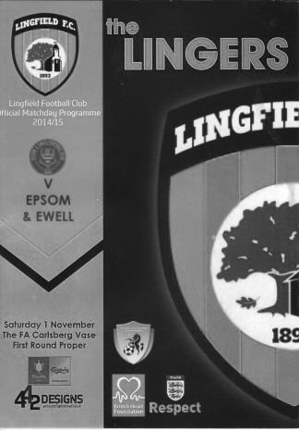
Still missing the suspended Sam Robinson, the club faced life without Dale Marvell who had left for Hanworth Villa in midweek, the unavailable Matt Robinson and the injured George Murphy and Ali Dewar, although on the positive side Taylor Smith was back in the squad while some excellent detective work by our Treasurer ensured that Dan Dean was not suspended for this match after all as the Surrey F.A. had double counted one of his bookings and no suspension was due!

Against a side that had been involved in some real goal-fests this season it was important to control the game in midfield, thus reducing their chances and hopefully providing more opportunities for our strikers. It was also key to get off to a good start, or at the very least not to have a bad one. Unfortunately we failed in all three of those challenges as cross from out on the left was met Kiernan, whose unchallenged header gave Michael Eacott no chance whatsoever from close range in just the sixth minute.

We responded well for a while. Matt Tanton, playing down the left flank, cut in and hit a low shot on target but the ball was beaten away for a corner by the home keeper and Sean White on the other wing was just unable to meet a cross from Mark Jarman. However, we looked vulnerable when the opposition came forward and Eacott was required to make a fine low save after 23 minutes. Five minutes later we were in real trouble as Luke Gaffney was beaten by his man and had no cover. As our young full back tried to catch his opponent, he appeared to just clip his heels and although the fall was a theatrical one, the referee was still of the mind that it was a foul and Kiernan gave Eacott no chance from the spot.

It was nearly three-nil moments later but the striker was unable to make a decent contact on the ball and Eacott was down to reach the ball. From there we had our best chance of the match when we had a throw on flicked on by Jarman after 34 minutes and Matt Ferdinando threw himself into the header which was somehow blocked at

point blank range by the keeper. Unfortunately our man was also injured in the subsequent collision and Alex McKay came on for him a minute or two later. A further sign that it was not going to be our day (if another one were required) came when Kyle Hough was put through on the left and while the angle was narrow, he just lashed at the ball and sliced it straight out for a goal kick.

However, the signs were that we might be able to get one back and then you never know. Those thoughts were abruptly ended in first half injury time when Kiernan scored his third goal when meeting a right wing cross and forcing the ball past Eacott.

To our credit we started the second half strongly, pushing our opponents down the hill for a while. In the 49th minute Jarman flicked on another throw ahead of the keeper but Hough's header towards the open goal was just reached by the leg of a Lingfield defender and cleared. A few minutes later Glyn put Smith on for Gaffney, reverting to three at the back. This was obviously a gamble, but at 3-0 down one that had to be taken. Of course it can leave you exposed at times and this happened after 62 minutes when from our own corner they broke away and Sintin finished clinically.

Tanton had to clear off his line soon after this before we had another chance from a corner when James Taylor reached a loose ball but was unable to keep his attempt down and the ball just cleared the bar. McKay suffered a similar fate from a header from a free kick that Jarman had flicked on and his replacement after 80 minutes, Ollie Shaw then created a chance of his own when robbing a defender and getting a shot away that the keeper deflected just wide of the post with his leg. However, after 84 minutes we did find the net when Smith beat the keeper to the ball and he laid the ball back to White who chipped the ball from twenty yards over the retreating keeper and defender, dropping just under the bar. It was a great strike and it was unfortunate that it didn't come at a more useful time as this game was already over by then.

Insult was then added to injury when Eacott jumped into a challenge and fouled the defender for a second penalty after 92 minutes. It wasn't his best tackle, and although I was some distance away, I thought we were going to lose our keeper to a red card, but the official decided that it was clumsy rather than malicious and thankfully the Lingfield striker didn't make too much of it either, The fact that Dean then scored the penalty was irrelevant unless you were keeping score, which by that time, many weren't.

So forty seasons after we went to Wembley Stadium for the first F.A. Vase Final we produced the worst result in our entire Vase history. Of all the previous 28 defeats in this competition we had only conceded five goals twice before, at home to Merstham in 1975/76 (4-5) and the fiasco at Cowes Sports where we finished with nine men (5-2). This result now eclipses that one and it remains an inescapable fact that we so frequently produce our worst form in Vase matches. Make no mistake, like St Francis, Chichester, Cowes, Ringmer, Herne Bay and Abingdon United before it; this result will "Linger" long in the memory.

Team: Michael Eacott, James Taylor, Luke Gaffney, Anthony Panayi ©, Dan Dean, Matt Tanton, Matt Ferdinando, Matt Farrell, Mark Jarman, Kyle Hough, Sean White

Subs: Alex McKay for Ferdinando (39), Taylor Smith for Gaffney (52), Ollie Shaw for Jarman (80)

Above and Below
Ryman League Division One South Table
up to date | P | W | D | L | F | A | Pts | GD
Faversham Town | 20 | 13 | 3 | 4 | 51 | 29 | 42 | +22
Burgess Hill Town | 16 | 12 | 4 | 0 | 36 | 12 | 40 | +24
Folkestone Invicta | 18 | 11 | 5 | 2 | 36 | 17 | 38 | +19
Merstham | 20 | 10 | 7 | 3 | 48 | 25 | 37 | +23
Tooting & Mitcham United | 19 | 10 | 3 | 6 | 38 | 22 | 33 | +16
Whyteleafe | 19 | 8 | 7 | 4 | 36 | 23 | 31 | +13
South Park | 19 | 9 | 4 | 6 | 37 | 33 | 31 | +4
Sittingbourne | 21 | 9 | 4 | 8 | 30 | 27 | 31 | +3
Chipstead | 19 | 8 | 6 | 5 | 29 | 26 | 30 | +3
Herne Bay | 21 | 9 | 3 | 9 | 32 | 32 | 30 | 0
Corinthian Casuals | 21 | 9 | 3 | 9 | 33 | 38 | 30 | -5
Whitstable Town | 21 | 7 | 8 | 6 | 36 | 37 | 29 | -1
Worthing | 17 | 7 | 4 | 6 | 27 | 25 | 25 | +2
Walton & Hersham | 19 | 8 | 1 | 10 | 22 | 32 | 25 | -10
Three Bridges | 19 | 6 | 5 | 8 | 26 | 45 | 23 | -19
Hastings United | 19 | 6 | 4 | 9 | 28 | 29 | 22 | -1
Carshalton Athletic | 20 | 6 | 4 | 10 | 23 | 27 | 22 | -4
Hythe Town | 20 | 5 | 6 | 9 | 31 | 35 | 21 | -4
Guernsey | 19 | 6 | 3 | 10 | 41 | 49 | 21 | -8
Ramsgate | 19 | 6 | 3 | 10 | 19 | 31 | 21 | -12
Redhill | 18 | 5 | 3 | 10 | 32 | 39 | 18 | -7
East Grinstead Town | 21 | 5 | 3 | 13 | 24 | 48 | 18 | -24
Horsham | 17 | 3 | 4 | 10 | 21 | 33 | 13 | -12
Walton Casuals | 18 | 2 | 3 | 13 | 22 | 44 | 9 | -22
Although Faversham top the table currently, it is the unbeaten Burgess Hill Town who are the team to beat. Already our favourites after knocking Sutton United out of the F.A. Cup, they were held up at Whitstable Town recently when they conceded an 88th minute equaliser in a 1-1 draw while Faversham lost 1-5 at home to Hastings United and were then held 3-3 by Walton Casuals, so there is no doubt right now who will be going up as Champions.

Folkestone Invicta are also in the hunt and defeated Corinthian Casuals 4-1 recently, who have slipped down from their earlier lofty position, while newly promoted Whyteleafe and South Park are right on the fringe of the promotion race with our landlords Chipstead a point back on them.

So could anyone else challenge Burgess Hill? Well, the stand out result of the week was Merstham’s 8-0 win over Guernsey on Tuesday and they are well placed. They host Tooting & Mitcham United today and a win there would really create some daylight for the top four.

At the bottom, Walton Casuals still look most likely to finally return to the Combined Counties League, but East Grinstead Town have pulled away a bit, leaving Horsham in their wake. I would be very surprised to see the Hornets drop down, but it happened to us a few years ago and we are of a similar size so you never know.

Above and Below
Combined Counties League Division One Table
up to date | P | W | D | L | F | A | Pts | GD
Farleigh Rovers | 14 | 9 | 2 | 3 | 30 | 20 | 29 | +10
Worcester Park | 13 | 9 | 1 | 3 | 35 | 17 | 28 | +18
AFC Croydon Athletic | 12 | 9 | 0 | 3 | 35 | 12 | 27 | +23
Banstead Athletic | 12 | 8 | 2 | 2 | 29 | 13 | 26 | +16
Ash United | 13 | 5 | 5 | 3 | 24 | 18 | 20 | +6
Bedfont & Feltham | 11 | 6 | 2 | 3 | 23 | 26 | 20 | -3
Staines Lammas | 11 | 6 | 1 | 4 | 26 | 18 | 19 | +8
Cobham | 13 | 6 | 0 | 7 | 31 | 19 | 18 | +12
Sheerwater | 13 | 5 | 2 | 6 | 18 | 28 | 17 | -10
CB Hounslow United | 15 | 4 | 3 | 8 | 21 | 34 | 15 | -13
Alton Town | 13 | 4 | 2 | 7 | 22 | 31 | 14 | -9
Epsom Athletic | 13 | 3 | 4 | 6 | 29 | 37 | 13 | -8
Eversley & California | 10 | 4 | 0 | 6 | 21 | 24 | 12 | -3
Chessington & Hook United | 8 | 3 | 2 | 3 | 19 | 19 | 11 | 0
Dorking | 11 | 3 | 0 | 8 | 18 | 28 | 9 | -10
Sandhurst Town (-3) | 16 | 2 | 0 | 14 | 21 | 58 | 3 | -37
Farleigh Rovers currently head the way in the division below us and their 1-0 win at Ash United on Saturday was a real six-pointer as they could have easily lost a large part of their lead with defeat at Youngs Drive.

Worcester Park kept up the pace with a 6-0 demolition of Epsom Athletic who are beginning to struggle this season. Right now only CB Hounslow and Sandhurst Town have dropped more points than them.

The other teams at the top met on Saturday with AFC Croydon Athletic defeating Banstead Athletic in a highly charged match as it was their first back at Mayfields Avenue, the spiritual home of their former club. This will surely provide the springboard for further success and I am certain we’ll see them up here next season. I wouldn’t rule Banstead out either, although clubs like Alton and Chessington & Hook have an awful lot of work to do to catch up with the leaders.

Since our last look at the tables Staines Lammas are now headed in the right direction and I wouldn’t write Bedfont & Feltham off yet, despite their recent 0-9 home defeat on the day when we played across the road from them.

At the bottom though, these are difficult times for Sandhurst Town, and although relegation is unlikely due to the FAs insistence on Step Six clubs having floodlights, which Farleigh, Worcester Park and Sheerwater do not, there could be a threat to the existence of the Division itself which we’ll find out more about in the near future.

Club Records - 22nd November
Date | Day | Competition |  | Opponents |  | Scorers
22/11/24 | Sat | Surrey Senior League | A | Walton | 2-2 | R.Sperring, R.Marlow
22/11/30 | Sat | Amateur Cup 4q | A | Whyteleafe Albion | 2-1 | B.Earl, G.Mackesy
22/11/47 | Sat | London League | A | Eton Manor | 1-3 | E.Watkins
22/11/52 | Sat | Surrey Senior Cup 3q | H | Malden Town | 7-2 | B.Goddard (3), S.Scott (3), V.Honey
22/11/58 | Sat | Corinthian League | H | Erith & Belvedere | 4-0 | T.Millard (2), B.Willis, J.Weaving
22/11/69 | Sat | Athenian League Cup 2 | H | Windsor & Eton | 1-2 | K.Jolly
22/11/75 | Sat | Athenian League 2 | H | Windsor & Eton | 5-2 | T.Tuite (2, 1 pen), A.Reid, B.Denman, T.Coombe
22/11/83 | Tue | Isthmian League 1 | H | Woking | 2-1 | S.Hill, P.Harding
22/11/86 | Sat | Isthmian League 1 | H | Tilbury | 3-2 | J.Stainer (pen), R.Purvis, M.Cossey
22/11/88 | Tue | Isthmian League 2s | H | Egham Town | 2-1 | K.Phillips, R.Strong
22/11/08 | Sat | Combined Counties  Premier Division | H | Badshot Lea | 2-0 | K.Hough (pen), R.Shoefield
Historical Decades
90 years ago – Epsom Town
22/11/24 | Sat | Surrey Senior League | A | Walton | 2-2 | R.Sperring, R.Marlow
80 years ago – Epsom F.C.
24/11/34 | Sat | Amateur Cup 4q replay | H | Redhill | 3-1 | T.Dunne, J.Jones, E.Hannam
70 years ago – War time Epsom Town
25/11/44 | Sat | South Eastern Combination | A | Walton on Thames | 0-7
60 years ago – Epsom F.C.
20/11/54 | Sat | Corinthian League | A | Edgware Town | 2-4 | D.Willoughby, B.Musto
50 years ago – Epsom & Ewell
21/11/64 | Sat | Athenian League 1 | H | Horsham | 5-6 | T.McGrogan, J.Eales, B.Mackay (3)
40 years ago – Epsom & Ewell
27/11/74 | Wed | F.A. Vase 2 | A | Horley Town | 2-0 | T.Tuite, T.Wales
30 years ago – Epsom & Ewell
20/11/84 | Tue | Isthmian League Cup 2 | H | Windsor & Eton | 2-1 | C.Miles, S.Hill
20 years ago – Epsom & Ewell
24/11/94 | Thu | Surrey Senior Cup 4q | H | Netherne | 1-3 | P.Meredith
10 years ago – Epsom & Ewell
20/11/04 | Sat | Isthmian League 2 | H | Clapton | 5-2 | C.Pritchard, A.Davidson, R.Shoefield, C.Read, L.Gay

History Corner – 22nd November
Our first three matches on this date were away from home, yet the next nine including today have been at home, so we haven’t travelled on this date since 1947!

84 years ago today we travelled to Whyteleafe Albion, an earlier version of the Whyteleafe we know today for an Amateur Cup tie. A 2-1 win enabled us to enter the First Round of the Amateur Cup for the very first time, where we would entertain holders Ilford.

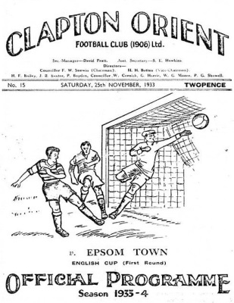
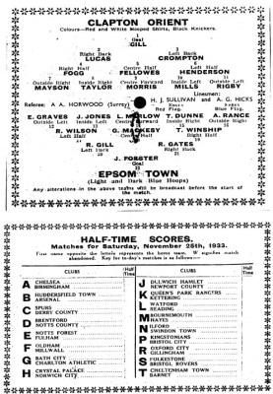
81 years ago this week we travelled to Clapton Orient for our only appearance in the First Round of the F.A. Cup. After a slow start we trailed 3-0 only to fight back to 3-2 and nearly force an equaliser before being caught on the break near the end and losing 4-2. Nearly 10,000 watched the match at the Lea Bridge Speedway Stadium which was their home before moving to Brisbane Road where they currently reside, first as Orient and now as Leyton Orient. (see programme pictured)

80 years ago this week we won 3-1 at home to Redhill in an Amateur Cup replay at West Street. This would prove to be the third and final time we would ever reach the First Round and Wimbledon would end the journey in January of 1935.

62 years ago today Bill Goddard scored a hat trick along with Stan Scott as Malden Town were crushed 7-2 in a Surrey Senior Cup tie at West Street. However, Goddard’s hat trick was far more significant as it was his fifth in five consecutive matches! “A World Record!” shouted the local papers. Maybe it was, but it could only have been a joint one as Reg Marlow also did exactly this for us back in 1926/27!!

50 years ago this week came the collapse to end all collapses as we hosted Horsham in an Athenian League match at West Street. We got off to a flyer with young seventeen year old former Glyn School pupil Johnny Eales scoring his first ever goal for the club and we led 4-1 at half time. We even extended that lead early in the second half before it all went pear shaped and we somehow contrived to lose 5-6!!

40 years ago this week the F.A. Vase run continued with a 2-0 win over Horley Town with goals from Tommy Tuite and Trevor Wales. The game had been postponed on the Saturday and as Horley didn’t have floodlights, the match had to be played at Molesey’s Walton Road, but it made no difference to the result!

28 years ago today following relegation from the Premier Division, many thought we would bounce back up, but it was late November and we hadn’t even won a match. Tilbury were right down there with us and it was a see saw game that we edged 3-2 with a late goal from New Zealand International player Mark Cossey. It made no difference though as we both went down anyway!

From behind the goal
Bedfont Sports 0-2 Epsom & Ewell
Combined Counties League – Premier Division
Saturday 8th November 2014

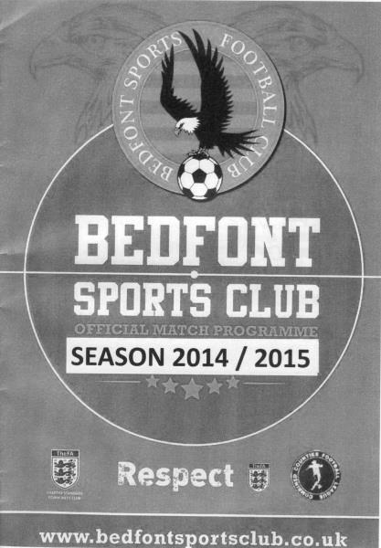
Miserable weather - great result!

What a difference a week can make! With a four game League losing streak and a Vase exit fresh in their minds, our boys put in a full shift, closing down every inch of space, and when the opportunities arose they made their opponents pay to exact full revenge. It should be remembered that it was Bedfont Sports that had started our losing run off when winning 1-0 at High Road a month ago.

Sam Robinson completed the final game of his four match suspension while Kyle Hough was also absent, but in his place came Taylor Smith, now appearing fully over his knee injury that he had been struggling with. Additionally, we saw the return of Alex McGregor, one of the most popular players the club has had in recent seasons, and once he recovered from a slow start, he became more and more influential as the main threat of a five man midfield with Matt Ferdinando and the returning Matt Robinson on either flank while Matt Farrell and Alex McKay protected our front four excellently. McKay in particular was superb today, even having time to get forward when the opportunity arose.

The weather was extremely windy on our last visit here; a 2-2 draw in March, and we were faced with similar conditions to start with before a tropical monsoon added another element throughout the second half. However, as the weather got worse, we got better and two goals in the second half were a deserved reward for the hard work put in.

The first half started very slowly with both teams understandably trying to keep the ball on the ground and trying to retain possession. However, both teams closed down the ball players really well with the result that much of the play went sideways for large parts of the match. For Epsom Ferdinando was our most prominent player, seeing a lot of the ball in the early stages of the match and he linked well with McGregor, sending two shots just wide of the far post. To be honest though, neither side were able to create much until the 43rd minute when a good cross from Robinson floated over the defender and into the path of Smith, but he couldn't get the ball out from under his

feet and his shot lacked power, being blocked and then gathered at the second attempt by the home keeper Richardson who had played so well against us in the earlier fixture.

The hosts responded almost immediately with a free kick that was met by a looping header which just dropped beyond our crossbar but from the next possession McGregor whipped in a deep cross from the right wing and from an almost impossible angle Smith headed the ball back towards goal and Richardson was required to claw it away before the half time whistle blew.

Clearly heartened by that little spell our boys came out for the second half and stepped up the tempo further as the rain started to fall. Two minutes into the half we had our reward when Robinson just beat the offside trap to reach the bye line and cross deep

where Ferdinando had a shot blocked and McKay's follow up effort was also charged down. Fortunately Smith would make sure it was third time lucky as he lashed the loose ball in from close range and we were ahead.

As the rain continued to increase in intensity Smith got through again from a Ferdinando pass but a last ditch challenge from a home defender prevented an almost certain second goal. However, the home side had also been stung into life and Dan Dean blocked a good move out on the right wing as the ball was about to come in.

We then needed to be alert to clear the ball just in front of Michael Eacott. However, this was about all the home side could muster and we broke down the left wing after 62 minutes. Although that attack was defended. McGregor then won the ball off the defender who was coming out with the ball and fed Smith who was then confronted with the pleasant surprise of seeing Richardson hopelessly exposed on the edge of his box, so he took it around him and passed it into the net with his left foot to double our lead.

A nasty stud injury to Ferdinando's shin ended his day prematurely although Sean White came on and was very lively himself. In fact he had the ball in the net after 78 minutes from a McGregor cross when either he or Smith, or perhaps both were adjudged offside.

The points weren't quite secured though and a low left wing cross for Bedfont went across the face of our goal and was met by a good shot at the far post but Eacott made his first real save of the day to block the goal bound shot and he was down to muddy his bright orange kit a minute or two later to make another save as the hosts had their final chances. Robinson curled a shot just on to the roof of the net a couple of minutes from time and whilst it would have been a great goal and the icing on the cake, two were sufficient this week.

Team: Michael Eacott, James Taylor, Matt Tanton, Anthony Panayi ©, Dan Dean, Alex McKay, Matt Ferdinando, Matt Farrell, Alex McGregor, Taylor Smith, Matt Robinson

Subs: Sean White for Ferdinando (67), Ollie Shaw for Smith (88)

Centre page for results

Centre page for results

Molesey F.C. – History
Molesey is both a village and a club steeped in history stemming back as far as the 1800's and a Molesey side won the Surrey Junior Cup in 1913; It was in 1953 that the senior club was officially formed when Molesey St. Pauls United joined forces with another Molesey village side to become Molesey FC. The club spent its early years in the Surrey Senior League with some degree of success in both league and cup competitions.

It was back in 1958 that the club last enjoyed a major honour when they won the Surrey Senior League just five years after their formation. Whilst they have sampled life in the Isthmian Premier Division it was all too brief and the club have ambitions to climb the pyramid once again and hopefully return to the Premier Division and maybe beyond. Molesey FC enjoyed the halcyon days in the early 60's with three appearances in the Spartan League Cup final and Jack Anders' Easter tournaments which featured both local and German sides were always both well supported and financially rewarding but there was little to cheer again until 1972 when the club reached the Spartan League final once again but lost to Bracknell Town at Egham Town FC.

John Sullivan was the man who changed the direction of Molesey FC when he took over following the clubs election to the Athenian League. A host of star names appeared for the club over the next few years including Cyrille Regis who later went on to gain England honours. Regis netted 27 goals in a very short time here before departing suddenly and unexpectedly to Hayes who quickly benefited when they sold him for £5000 to West Bromwich Albion. During Sullivan’s reign Molesey enjoyed a fantastic record-breaking season in the Premier Midweek Floodlit League in 1976/77.

The club won nine out of ten group matches, broke the aggregate goal scoring record and when Chris Proctor netted five times against Hayes it was an individual scoring record. Despite Sullivan's obvious eye for good players and some excellent runs in the FA Vase, Molesey failed to win a trophy during his time in charge although they did progress to the new Isthmian League set-up in 1977. They finished in the top half of the table for the first four seasons and only missed out on promotion to Division One in 1978 when they drew 1-1 at home to Camberley in their final game of the season, a game they needed to win.

After Sullivan's departure a yo-yo existence followed for many years and the club almost went out of business during the mid 80's under the chairmanship of Graham Pearce; his untimely but ultimately necessary departure forced three long serving members to take over and those three gentlemen with the backing of the members saw the club through a tough period; what they did not know was how inspirational their decision to appoint Martin Eede was to prove.

Eede arrived in 1987 and helped turn the club around. Together with his right hand man Ray Best, Eede was responsible for a gradual improvement in the clubs playing fortunes and that improvement reaped its' due reward when Molesey were runners-up to Yeading in 1990 and gained promotion to Division One.

Eede stepped aside to become football chairman and Tony Dunne joined the club to lead them through an incredible spell; again with Ray Best in the back room staff alongside Richard Higgs the club earned two Southern Combination Cup successes, promotion into the Premier Division and runners-up in the League Cup final in 1993. This was the clubs best ever season and included a club record eleven straight victories. This was also the season in which the club made its only foray into the 1st round proper of the FA Cup but they were beaten by Bath City after a glorious run.

Off the field Eede became the principal figure in cajoling the clubs members and supporters through hours of hard work as they carried out the necessary ground improvements required for our promotion to the Premier Division. Dunne eventually left due to business pressures but former Sutton defender John Rains kept the momentum going and in what was an exciting season the club finished 8th in the Premier Division, their best ever league placing at the end of 1994/95.

Sadly Molesey lost the services of both Rains and Eede and two relegations in three years saw them back where they were ten years earlier. South African businessman Norman Clark joined the club in 1997 but departed in January 2004 after seven somewhat controversial years. Ray Best returned to the club during the ex-football chairman's early years and his influence was again obvious as he took the side into the top half of Division One before a somewhat surprising departure, one which Molesey supporters found difficult to comprehend given the sides position at the time.

Several managers came and went during Clark's tenure at the club as Molesey fought to gain promotion once again and Pete Johnson was appointed as manager in May 2002; under his command the club enjoyed their best FA Cup run for ten years; by mid October they had already beaten Hassocks, Fisher Athletic, Hitchin Town and Chertsey Town scoring twelve goals and conceding just two defeats in their last fourteen matches he walked away when he seemed set to lead us into the new campaign while Steve Moss's reign was brief and his departure very acrimonious and public.

Everton and Wales legend Neville Southall took the reigns on a caretaker basis, before the club appointed Steve Beeks as boss in October 2003. However, the club was shrouded in off-pitch problems, and following a long term investigation by the Football Association, who insisted the club hold an EGM, Norman Clark resigned as Club and Football chairman in January 2004. Steve Beeks and his back room team stayed on with the full backing of the new committee and he became the clubs longest serving manager since Martin Eede and was greatly admired around the club.

Off the field, there was tremendous progress around the ground, by some amazing people and club volunteers. The much-needed new clubhouse, driven by Chairman John Nunn, was finally opened in April 2006. However, the ongoing legal battles took their toll, with the club being forced to significantly reduce its playing budget for the 2007/08 season, resulting in the resignation of Beeks, who felt he had taken the club as far as he could.

Sadly, the club struggled both on and off the pitch; key off-field personnel left during the Summer and relegation seemed inevitable from an early stage, as the team begun the new year on a torrid run that saw them amass just four points from the opening sixteen games, culminating in relegation to the Combined Counties Leagues, a very hard pill for all to swallow after 30 years in the Isthmian League.

Webb continued as manager in 2008/09, once again assembling a squad virtually from scratch. His new-look side took time to adjust to life in the Combined Counties League, although a fine run either side of Christmas took the club to the outskirts of the promotion race, before injuries and loss of form took their toll, resulting in a mid-table finish. The club enjoyed moderate success in cup competitions, reaching the semi final of the league cup, and bowing out of the F.A. Vase at the third round after a long trip to Norfolk to face Dereham Town.

Molesey started 2009/10 with Webb continuing as manager, the Moles began the season with a settled side, a top six finish being the aim. After a dreadful start the ship was settled and the Moles finished the season relatively successfully.

The Moles now look to break out of the Combined Counties League sooner rather than later and seem set to be perennial challengers for the title. The Molesey committee are continuing to try and build links with the local community and steady the club after decades of turbulence.

EL Records Premier Challenge Cup
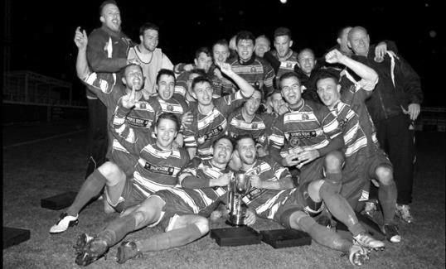
Second Round
Alton Town | 13/12 | Farnham Town
Ashford Town (Mx) | 5-0 | CB Hounslow United
Badshot Lea | 10-2 | Dorking
Bedfont Sports | 1-1+ | Cove
Cove won 4-1 on penalties
Camberley Town | 0-0+ | Molesey
Camberley Town won 3-0 on penalties
Chertsey Town | 0-7 | Windsor
Cobham | w/o Horley | Horley Town
Colliers Wood United | 3-0 | Bedfont & Feltham
Epsom & Ewell | 2-1 | Knaphill
Epsom Athletic | V | Banstead Athletic
Eversley & California | 2-4 | Ash United
Frimley Green | 1-0+ | Spelthorne Sports
Hanworth Villa | 2-3 | Guildford City
Sheerwater | 1-6 | Mole Valley SCR
Westfield | 4-0 | Farleigh Rovers
Worcester Park | 29/11 | Chessington & Hook United
Third Round
Westfield | V | Cove
Badshot Lea | V | Guildford City
Worcester Park / Chessington & Hook | V | Epsom Athletic / Banstead Athletic
Alton Town / Farnham Town | V | Mole Valley SCR
Frimley Green | 9/12 | Epsom & Ewell
Windsor | 2/12 | Ash United
Colliers Wood United | 17/12 | Horley Town
Camberley Town | 9/12 | Ashford Town (Mx)

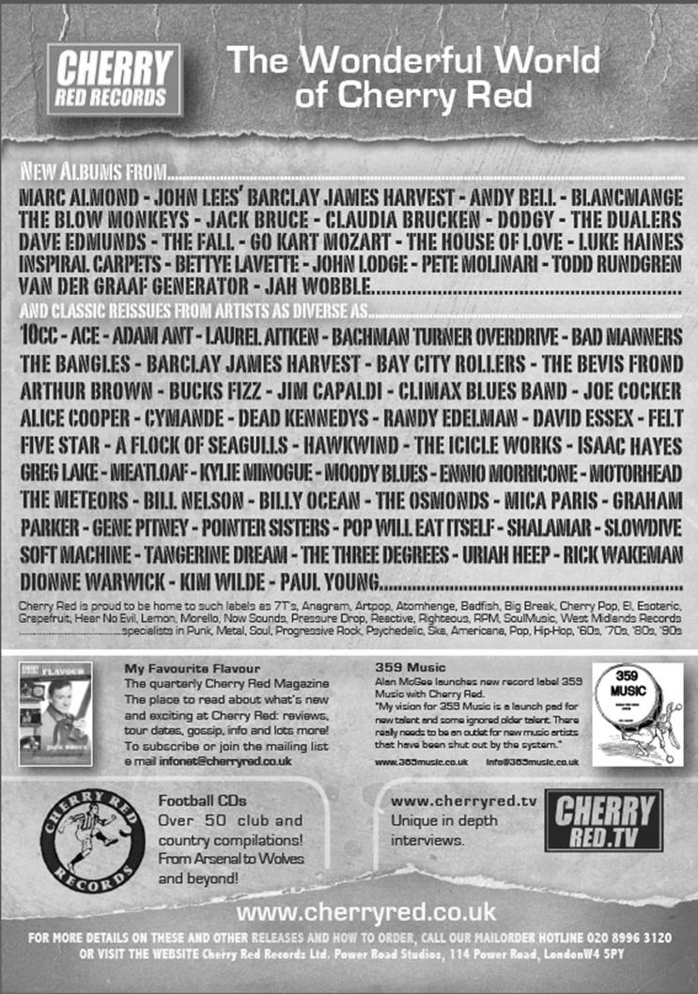
Player Sponsorship
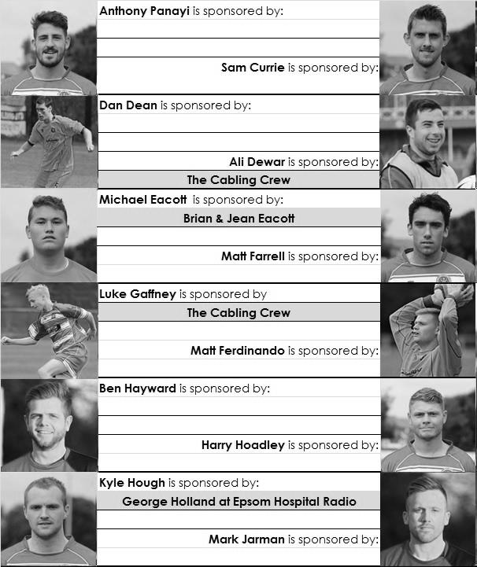

Here is the latest list showing all of the players and Management available for sponsorship. Sponsorship costs £40 so if you want to help the club, the player and get your name in the programme for the season, just let us know before they go!

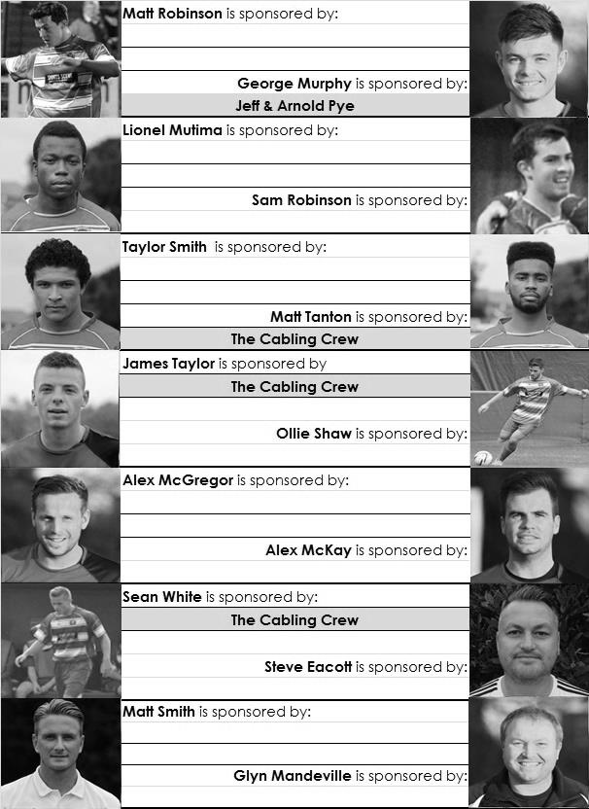

Every Opponent A-Z
Over the years we have played many, many different opponents. Exactly how many is a difficult question, as it all depends on your definition. Are Camberley & Yorktown different to Camberley Town, or are Epsom Town different to Epsom F.C. or Epsom & Ewell F.C.?

In my analysis I have classed them as the same team, and will work through them all from A to Z. Some we have played many times, whilst others we have met maybe just once or twice. Enjoy!

Malden Town: Played 14 - W7 D4 L3 - F36 A20 - PPG - 1.79 - Good

Malden Town disappeared suddenly without leaving a trace in the late eighties, yet just over a decade before then, they were very close to us in the Surrey Senior League table, and that was when we were very good!

Of course, they go back further than that, and they joined the Surrey Senior League in 1950/51. We first met on Saturday 22nd November 1952 and thrashed them 7-2 in the Surrey Senior Cup with Bill Goddard scoring his fifth successive hat trick (see today’s historical pages for more detail). We then made our first visit to Manor Park for an Amateur Cup tie in October 1953, winning easily 6-1 with Bill Wiles scoring four goals and Reg Oakes, uncle of our former Treasurer Rob, scoring the other two.

A bigger match occurred in February of 1954 after we had defeated Addlestone we were expecting to face Sutton United in the Quarter Final of the Surrey Senior Cup, only to find that Malden had knocked them out and we’d be going there instead! We won 3-0 and would eventually reach the Final that year.

We defeated them on three more occasions, knocking them out of the Amateur Cup three years in a row from 1955 to 1957 before they had their first success over us in December 1965 with a 3-2 Surrey Senior Cup win at Manor Park.

The next time we met it was as equals, as members of the Surrey Senior League where it has to be said they were the only team that gave us trouble. Champions Westfield couldn’t beat us, but Malden could, triumphing 2-1 at Manor Park in May 1974 and knocking us out of the Charity Cup at the Semi-Final stage after a replay. We did have success of our own though as we defeated them 2-1 after extra time at Walton & Hersham’s Stompond Lane ground in the League Cup Final.

Our final two meetings came at the end of a hard and busy 1974/75 season with both games being played at West Street and both being drawn. That season we won all of our League games except a shock home defeat to Virginia Water and these two draws!

They stayed in the Surrey Senior League which would become the Combined Counties League, (becoming Champions in 1980/81 and following up their titles in 1958/59 and 1970/71) until 1992 when they were runners-up but then folded due to the loss of their ground. No trace exists of this once proud local club, although Manor Park remains as an open space clearly visible from the train line that runs near it that heads to Malden Manor from Motspur Park.

Margate / Thanet United: Played 3 - W2 D0 L1 - F10 A4 - PPG - 2.00 - Very Good

Our club has met Margate on three occasions, all at home and all significant for different reasons.

We first met Margate in 1955 for a big F.A. Cup tie at West Street. They were a professional Kent League side although we had already knocked Dover out from their league in an earlier round, mainly due to heroics from our young keeper Geoff Porter, so wouldn’t have been daunted by the challenge.

However, four weeks after the Dover win Geoff found himself transferred from hero to villain as a result of a poor second half after Ray Colfar had put us ahead in the first. One goal appeared to be very poorly handled by Porter but it only transpired after the game that he had in fact broken his thumb before half time. “Get through it” he was told, but clearly his failure on the day was as a result of the injury.

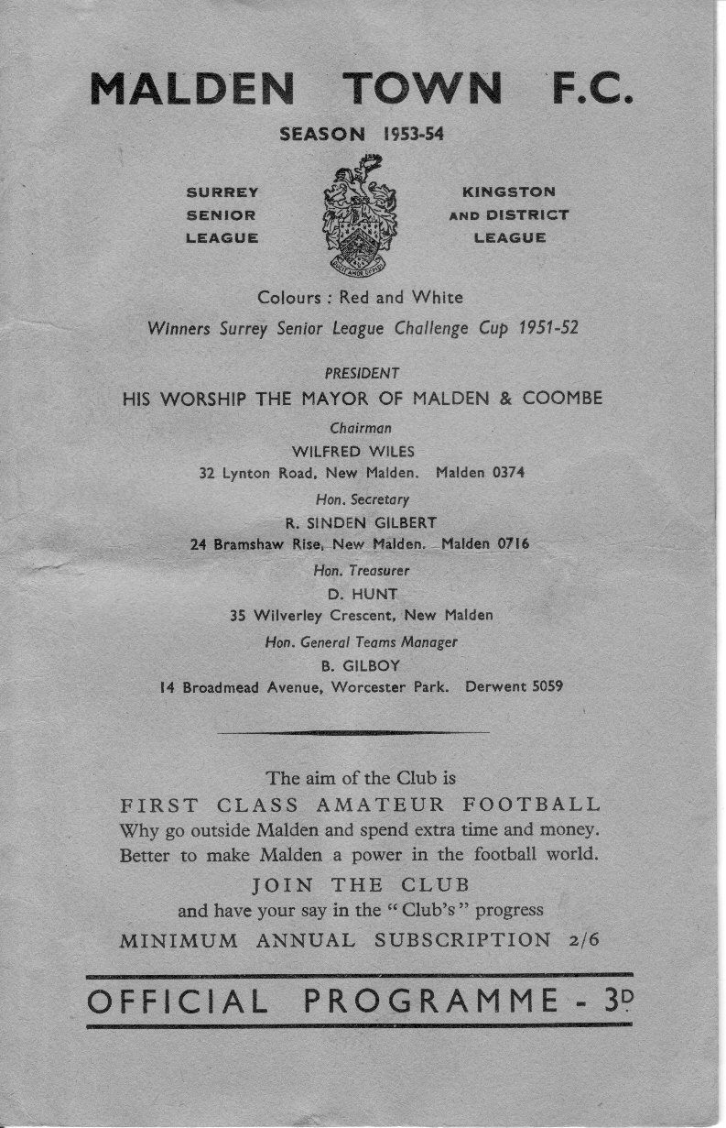
As it turned out, the injury had a profound effect on his life. His treatment by his team mates convinced him that there was more to life than football and he went out and joined the police force instead, never playing for our club again. When I first met Geoff in 2006 he was able to show me the disfigured lump that he still had on his thumb! Despite being nearly eighty back then he still remembered how harshly he had been treated!

The next meeting was an F.A. Cup tie in October 1980, refereed by a young David Elleray at West Street with Tommy Tuite scoring twice and Gerry Archer scoring the other goal in a 3-1 victory. A further victory over Ashford Town (Kent) ensured only our second ever visit to the fourth qualifying round but Enfield ended the dream with a 5-0 victory at Southbury Road.

For a couple of seasons in the early eighties the club, by now in the Southern League, changed their name to Thanet United and it was in this guise that we met them for the third and final time in our history, winning 6-0 in an F.A. Trophy match with Tommy Tuite scoring a hat trick on his 27th birthday. The run would eventually end in February 1982 at home to Altrincham in the last 32, our furthest ever progress. This 6-0 win was particularly significant for me too as it was my second ever game. Having lost the first one that I had watched seven days earlier, this result got me hooked and I am still here!

Left: the programme from our Surrey Senior Cup Quarter Final at Malden Town from 6th March 1954

Match and Ball Sponsorships – 2014/15
Opponent | Date | Match Sponsor | Ball Sponsor
Raynes Park Vale | 05/08/14 | Club President - Stella Lamont
Horley Town | 25/08/14 | Epsom & Ewell F.C. Management Committee
Croydon (FAC) | 30/08/14 | Media Officer - Richard Lambert
Frimley Green | 13/09/14 | Dave Gaffney and friends
Guildford City | 30/09/14 | The Jarman family
Mole Valley SCR | 07/10/14 | Mark and Carmel Murphy
Bedfont Sports | 11/10/14 | Epsom & Ewell F.C. Colts
Knaphill (LC) | 14/10/14 | Geoff and Steve Dyke
Ashford Town (Mx) | 18/10/14 | The Building Shop, Bookham
Chertsey Town | 28/10/14 | In Memory of Bob Bexley
Molesey | 22/11/14 | The Cabling Crew 0208 -224 4110
Camberley Town (SSC) | 02/12/14 | In memory of Liz and Doug Burns
Hanworth Villa | 06/12/14
Spelthorne Sports | 16/12/14
Windsor | 03/01/15
Farnham Town | 17/01/15
Westfield | 31/01/15
Camberley Town | 07/02/15
Hartley Wintney | 21/02/15
Cove | 07/03/15
Badshot Lea | 21/03/15
Colliers Wood United | 04/04/15
Knaphill | 18/04/15
For League, League Cup and Surrey Senior Cup Matches:

Match sponsorship - £40.00 Match ball sponsorship - £25.00.
Combined Offer of Match and Match Ball sponsorship for £55.00.

For F.A. Cup and F.A. Vase matches:

Match sponsorship - £50.00 Match ball sponsorship - £30.00.
Combined Offer of Match and Match Ball sponsorship for £65.00.
----------------------------------------------------------------------------------------------------------------------------
Sponsorship includes

Admission, programmes, advertising (if required) and hospitality.

If you are interested, just speak to a Committee Member, you know where we are!
Alternatively, drop me an email at: richard.c.lambert@gmail.com

F.A. Vase
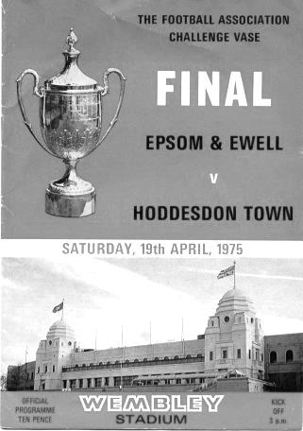
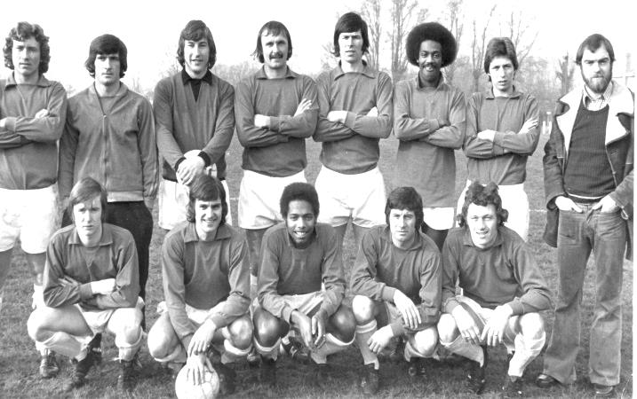
First Round Proper – 1st November
Ashford Town (Mx) | 2-3 | Loxwood
Chertsey Town | 1-2 | Horley Town
Chessington & Hook United | 2-1+ | Camberley Town
Colliers Wood United | 4-3+ | Ringmer
Farnham Town | 3-3+ | Abingdon United
Abingdon United | Replay 5-1 | Farnham Town
Horsham YMCA | 3-1 | Bedfont Sports
Lingfield | 5-1 | Epsom & Ewell
Littlehampton Town | 4-2+ | Guildford City
Lordswood | 0-1 | Knaphill
Pagham | 2-1 | Spelthorne Sports
Raynes Park Vale | 1-3 | Westfield
Windsor | 1-4 | Highworth Town
Second Round Proper – 22nd November
Eastbourne United | V | Horley Town
Hanworth Villa | V | Knaphill
Pagham | V | Colliers Wood United
Westfield | V | Tunbridge Wells

From behind the goal
Cove 1-0 Epsom & Ewell
Combined Counties League – Premier Division
Saturday 15th November 2014

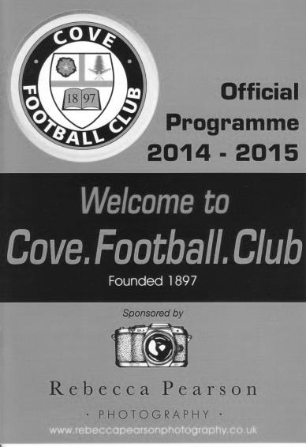
Salts learn lesson the hard way against uninspiring League leaders

In recent weeks we have been up against some of the teams at the top, but Cove the League leaders were made to look very ordinary by a high tempo Salts performance. However, our achilles heel this season came back to haunt us and yet again one defensive error cost us as a result.

Sam Robinson came back into the starting line up in place of the injured Taylor Smith who appears to be having further knee trouble, while George Murphy returned to the starting line up, moving Dan Dean into midfield to cover the absent Alex McKay but otherwise it was an unchanged eleven from the win at Bedfont Sports on Saturday.

The game was played on a heavy pitch at Oak Farm which had coped fairly well with the recent heavy rain but was still a bit uneven. Still we nearly took the lead in the first forty seconds when a good left wing cross was met by a glancing header from Matt Robinson that just went beyond the far post. He was then unceremoniously dumped by a late challenge after just eleven minutes which really should have received the card. One thing was clear, we weren't going to get any protection from the officials today!

Robinson was causing the home defence a lot of trouble with some good runs. Matt Ferdinando put him through on one occasion but he hit his shot at goal way too early when he could have taken it another twenty yards first before brother Sam met a far post cross with a header that was just wide. We had a scare when Murphy missed a header and their striker put his shot wide of Michael Eacott before there was a similar error at the other end but as Matt Robinson bore down on goal he telegraphed his shot and the keeper, Freeman-Johnson was down to block the shot. Moments later James Taylor flicked on a Sam Robinson throw but the ball was just too far ahead of the incoming Ferdinando.

After 36 minutes Ferdinando was involved again as he closed down a back pass and under pressure their keeper sliced the kick almost straight to Matt Robinson, who then cut inside his defender but as he shot the ball at goal, he scuffed it and it was easily cleared. However, an even better chance was just around the corner after Matt

Robinson had done well on the left wing and he pulled the ball back into the path of Alex McGregor but instead of drilling the ball in he chose to side foot it and it bobbled on him and went over the bar from just eight yards!

It was an impressive first half performance and Michael Eacott hadn't even been required to get his gloves dirty by the time we went off, but you wondered whether the missed chances would come back to haunt us and within eight minutes of the second half we had our answer when a deep left wing cross found Liam Eagles at the far post who had ages to put his downward header past the helplessly exposed Eacott. It was a sickening goal to concede; not only because of the complete absence of marking, but because we had been so well in control.

To be fair though, after this we soon got back on top and the hosts were restricted to very little throughout the remainder of the match. Matt Tanton made a great run down the left wing and as he emerged from the fog that had recently appeared on the ground he pulled the ball back to Sam Robinson whose shot was high and wide before Ferdinando controlled a ball in from the left but his shot was blocked into the path of Matt Robinson who didn't realise the ball had reached him and the danger was cleared before he could react.

George Murphy was next to appear on the left wing and he put in a great cross which was met by James Taylor but the header went straight at the keeper. The introduction of Kyle Hough for Ferdinando meant a move to the right wing for Matt Robinson where he sent in a dangerous low cross that just eluded our man but was collected at the far post by McGregor who set up Sam Robinson but his shot was only just over the junction of post and crossbar.

A Cove free kick was blocked by the wall although a shot from the rebound fizzed just over our bar but the threat was all around the home goalmouth. A Hough header from a deep right wing cross was blocked by a defender's shoulder before the follow up from Matt Farrell was also blocked. From the counter attack a shot from the right beat Eacott but was cleared off the line by a defender in the gloom. Farrell was again on target with a header from a Matt Robinson cross but although it was well guided it didn't have the power to beat the keeper and right at the end Farrell hooked on a Tanton cross but the ball wouldn't quite drop for newly introduced substitute Sean White.

At the end of the day Epsom weren't beaten by their opposition, who were decidedly average and won't be at the top come season's end. They were beaten by their inability to take chances and until we do, we will find ourselves coming up short against those teams at the top who manage to find a way to win even when not playing their best.

Team: Michael Eacott, James Taylor, Matt Tanton, Anthony Panayi ©,
George Murphy, Dan Dean, Matt Ferdinando, Matt Farrell, Alex McGregor,
Sam Robinson, Matt Robinson

Subs: Kyle Hough for Ferdinando (70), Sean White for McGregor (83)

From behind the goal
Mole Valley SCR 2-5 Epsom & Ewell
Combined Counties League – Premier Division
Tuesday 18th November 2014

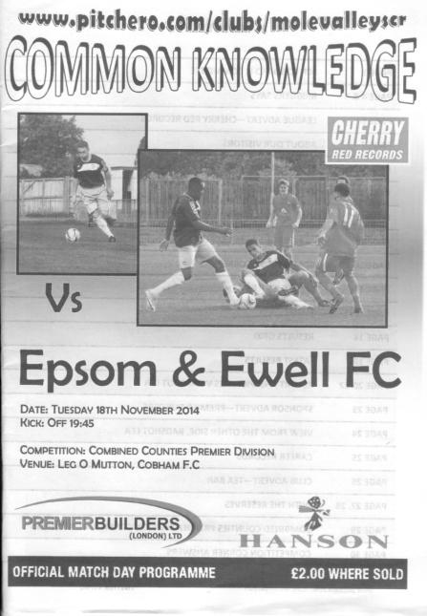
Hough hits top form as Salts smash Valley for five

In recent weeks the only thing stopping the Salts has been the ability to take the chances that came their way. Apart from the Lingfield match, games have been competitive and even but have just gone the way of the opposition. Against Mole Valley we showed what we are truly capable of once again and this performance was right up there with the Knaphill and Spelthorne away wins and could arguably be ranked higher as we were still missing the injured Taylor Smith up front.

One of the players who has received some criticism for the poor strike rate was our long-serving striker Kyle Hough, but he answered any critics out there with an excellent hat trick and bearing in mind that he is not yet 27, who knows where he will end up on our lists by the end of his career.

Of course it wasn't all about Hough. Sam Robinson capped another impressive display with another goal and Steve Rowe made his first appearance for the club in over three years at left back and sealed down that area completely. Ironically, his debut came at Merstham against the same opponents! The rest of the team played superbly and Captain Anthony Panayi also came close to marking a great performance with a goal too.

This game sparked into life almost immediately and it was as early as the fourth minute when a super right wing cross was met at the near post and headed up into the top corner by Matt Ferdinando. Two minutes later we had extended the lead when Robinson's low cross found Hough in far too much space and he just had to turn and shoot clinically, giving the keeper no chance. The hosts were in disarray and George Murphy was unfortunate to send another superb Robinson right wing cross just beyond the far post with a header. It wasn't to be Murphy's day though as he picked up an injury just before half time and had to come off at the break.

We nearly scored again in the 18th minute when a glancing header from a corner was

blocked on the line out to Hough who saw his effort blocked to James Taylor who was then unlucky in seeing his effort blocked by a combination of a defender and the post. Alex McGregor then sent a shot towards the top corner after good work from Robinson but the keeper Dilley was able to make the save.

Incredibly, after all this domination, Mole Valley SCR pulled a goal back in the 29th minute with a really good strike from Scott Robson that Michael Eacott did well to even get a glove on, although he will have been less impressed with his attempt for the shock equaliser five minutes later from Andy White, although we were carved open a bit too easily so blame should be shared across the defence for that one.

With momentum swinging wildly towards the home side, this was going to be a good test for our boys although our situation was made easier by an error by Dilley just thirty seconds after the equaliser. As Hough closed on him, and maybe conscious of an injury that had forced him off on Saturday, he didn't gather the ball cleanly, leaving Hough the job of cutting outside the covering defender and scoring, which he did easily.

The second half started with Alex McKay coming on for Murphy and Dan Dean slotted back in alongside Panayi with McKay protecting the back four. It worked a treat and we were rarely troubled, although the half started more evenly in terms of possession so with just a one goal lead and mindful of what had happened in the first half, we had to be careful. Panayi was just over with a near post header from a corner in the 57th minute and ten minutes later Ferdinando beat three or four people on a mazy run before passing to McGregor whose stinging shot was turned away for a corner.

Although the corner was cleared, there was some great interplay with McGregor, Robinson and then Hough who was brought down in the act of shooting. This was one of those occasions where being behind the goal gives me a better view than the official and I have to confirm that it was clumsy but a little harsh as Hough had managed to get a shot away, but kicked the ball against his other foot. Either way, the penalty was awarded this time and Hough scored a completely different penalty to his usual regular options, which I won't disclose here. Needless to say the keeper had no chance whatsoever and after 71 minutes we had some daylight. Kyle's hat trick was his fifth for the club, all of which have been scored away from home. In fact, since our last home hat trick in January 2009 we have had nine further hat tricks and all have been away!

There was just time for arguably the move and goal of the match after 81 minutes. Robinson made a great leap to head on a ball from defence out to Ferdinando on the right. He then attacked and rolled the ball across the edge of the area back to Robinson who swept the ball into the bottom corner as easy as you like from 20 yards. It was a really nice goal and put the stamp on a fine team performance and the visiting Molesey contingent at the game will be a little more concerned about Saturday's upcoming home match than they would have been beforehand!
Team: Michael Eacott, James Taylor, Steve Rowe, Anthony Panayi ©, George Murphy, Dan Dean, Alex McGregor, Matt Farrell, Kyle Hough, Sam Robinson, Matt Ferdinando

Subs: Alex McKay for Murphy (46), Ollie Shaw for Hough (89),
Sean White for McGregor (91)

Our New Website
Have you seen our website?

For those who are unaware, our website, now over a year old, contains everything you could possibly want to know about the club and an enormous amount you may not have been aware of!

Our previous site still exists, but as a photo archive only, housing the enormous wealth of pictures provided by Gemma Jarman, our Club photographer. In addition, there are over a thousand historical images of teams, players, action shots and programme covers.

As you can tell from the screenshot of our front page, there is a substantial amount of information all available at the touch of a button, which is also very useful if you own one of those new touchscreen personal computers that are becoming more and more popular these days.

If you are a supporter, please pass the address on to anyone you know that has ever expressed an interest in the club, especially those who don’t visit any more. You never know, some of them might be inspired to come along too, and bring their friends etc.

http://www.eefconline.co.uk/

Salts Super Six Predictor
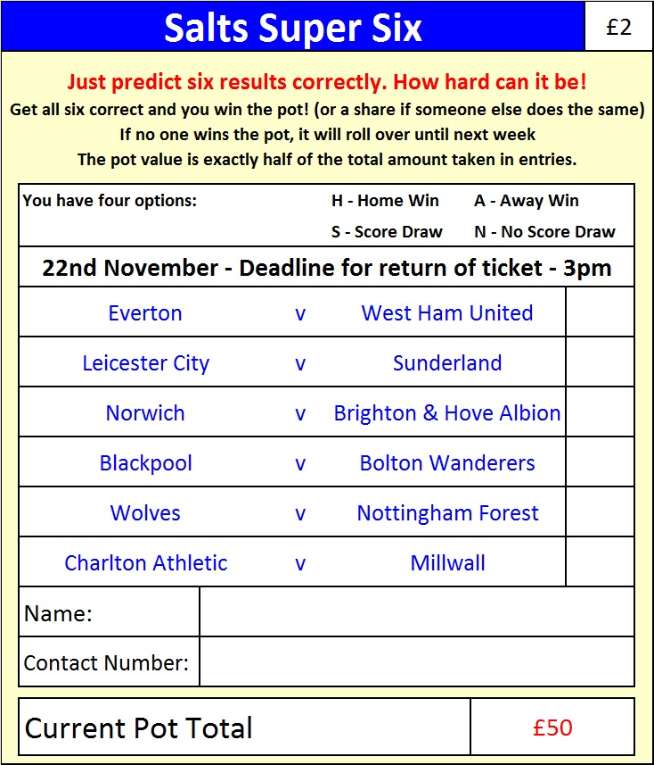

For a while now we have been looking to create something a bit different to the Golden Goal that we offer on a match day.

Well now it’s here! The Salts Super Six Predictor competition is easy to play and you don’t even have to be at the game! To win, you simply need to predict the results of six matches correctly from the four options, fill in the form and make sure it is back with one of our distributors before 3pm on Saturday 22nd November.

If you are a club regular, you just need to place your name on the sheet, although if you aren’t, then we’d need a contact number from you. We will announce any winners on the website by the Monday 24th November at the latest too, so don’t worry, we won’t miss you! The prize pot starts at £50 but will go up, if unclaimed, by the cost of 50% of all the sold tickets. In other words, if we sell 100 tickets before the deadline, and the pot isn’t won, then the next prize will be £150! You’ll always know the prize available before you enter.

Please note that if there is more than one winner, the prize pot would be shared by the number of winners.

All you need to do now is have a go. You can enter more than once if you like.

Good luck!

Combined Counties League – Premier Division
Saturday, 22nd November 2014 - Kick-off 3.00 p.m.
Epsom and Ewell  (Royal Blue & White hoops) | V |  | Molesey  (All White)
 | NUMBERS
Michael Eacott |  |  | Liam Allen
James Taylor |  |  | Joe Pratley-Jones
Matt Tanton |  |  | Luke Elliott
Anthony Panayi |  |  | Ollie Robinson
George Murphy |  |  | Moses Spencer
Dan Dean |  |  | Craig Lewington
Matt Ferdinando |  |  | Tom Windsor
Matt Farrell |  |  | George Windsor
Taylor Smith |  |  | Dre Grobler
Kyle Hough |  |  | Staf Palmer
Sam Robinson |  |  | James McShane
Alex McGregor |  |  | Matt Baxter
Matt Robinson |  |  | Ashby Charles
Sean White |  |  | Jamie Linegar
Luke Gaffney |  |  | Ross Chalke
Ollie Shaw
Ben Hayward
Ali Dewar
Mark Jarman
Steve Rowe
Glyn Mandeville | MANAGER |  | Steve Webb
Matt Smith | ASSISTANT |  | Peter Lelliott
Steve Eacott / Alex McKay | COACHES |  | Adrian Brown
Ken Jones | PHYSIO |  | Alan Maynard
REFEREE: J.Hurst (Camberwell)
ASSISTANTS: M.Ford (Sutton), R.Van Niekerk
Today’s Match and Match Ball are sponsored
by The Cabling Crew 0208 -224 4110

OUR NEXT VISITORS TO HIGH ROAD
Camberley Town
Tuesday 2nd December 2014 - Kick-off 7.30 p.m.
Surrey Senior Cup – Second Round

